International Business Management
2nd Seminar Work
Globalization Pros and Cons
Judit Galambos/David Parker

Reading task 1
McDonald’s plans 25 new locations across Ireland in major $175 million expansion 10:53 ET, 04 Mar 2026
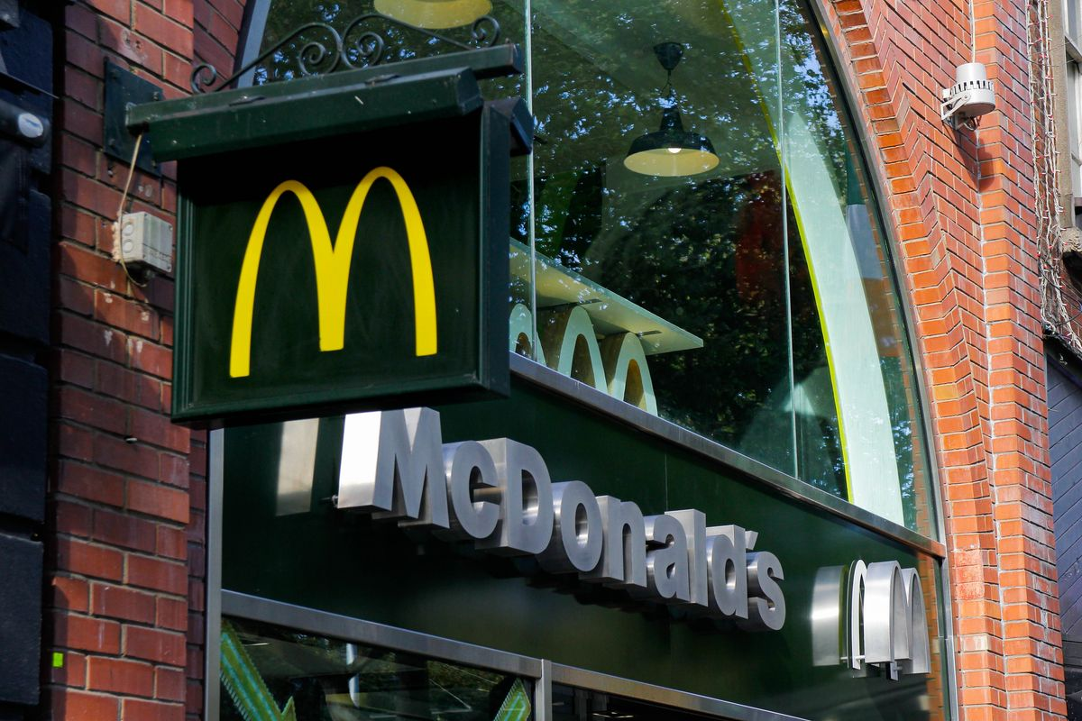
Ahead of its 50th birthday in Ireland in 2027, McDonald's has unveiled a €150 million (about $175 million) investment plan that includes five new restaurants per year and investments in current locations.
The fast food giant is investing €150 million into Irish expansion, opening 25 restaurants in the next five years
McDonald's has announced that it's investing €150 million (about $175 million) in opening 25 new restaurants in Ireland over the next five years, which will create about 1,750 jobs.
This development plan was unveiled ahead of the fast food titan's 50th milestone birthday in Ireland in 2027. Affectionately known as "Maccie's" by Irish McDonald's fans, the company also revealed that it intends to open five new restaurants per year over the next five years.
Mike Spencer, the Vice President of Development at McDonald's UK and Ireland, had a statement after the announcement: "The outlook for McDonald's in Ireland is very positive, and we have a clear plan to invest more than €150 million here over the next five years."
Spencer also added, "We plan that our 50th anniversary in Ireland next year will coincide with the opening of our 100th restaurant in Ireland."
McDonald's has already started this ambitious expansion plan with a recent opening. Just last month, its newest restaurant welcomed customers in New Ross—located in southwest County Wexford.
This is just the first of the fast food giant's five openings planned for 2026, though the locations of the other four restaurants haven't been revealed yet.
McDonald's further investment plans in existing Irish locations
While the news of McDonald’s future restaurants are sure to be exciting for customers across the country, the company already has 96 restaurants throughout Ireland, reported by The Irish Times.
These are currently independently owned and operated by 18 Irish franchisees and employ over 7,000 people. Fortunately, along with McDonald's Irish growth plan, those operations will also be receiving investments from the company.
McDonald's funding will cover the recent €3 million (about $3.5 million) refurbishment of its Cork Douglas location, which is led by local franchisee Jim Ronayne and reopened at the end of 2025.
This refurbishment was highlighted at 'Beneath and Beyond the Golden Arches,' a special event that "celebrates McDonald's economic and community impact" in Cork and across Ireland, according to a company press release.
At the event, the Minister of State at the Department of Transport and the Gaeltacht and T.D. for Cork South-Central, Jerry Buttimer, addressed attendees on the significance of continued regional investment and employment.
Buttimer said: "Today's announcement from McDonald's is a strong endorsement of the value of long-term investment in Ireland's communities, delivering tangible benefits for the economy through the creation of 1,750 new local jobs over the next five years."
"Over the past five decades, McDonald's has played a significant role in communities across Ireland - sustaining local employment, supporting Irish farmers and the agri-food sector, and investing in regional initiatives and charitable causes that strengthen social and economic resilience nationwide," added the Minister.
"I particularly welcome McDonald's continued commitment to Cork, demonstrated through its €3 million investment in the Douglas restaurant."
Questions and Model Answers
1. How much money is the company planning to invest?
2. How many new restaurants will be opened?
3. How many jobs are expected to be created?
4. When will McDonald's celebrate its 50th anniversary in Ireland?
5. How many McDonald's restaurants currently operate in Ireland?
6. Who owns and operates these restaurants?
7. How many people currently work in McDonald's restaurants in Ireland?
8. What additional investments will the company make besides opening new restaurants?
Discussion
Why would a global company choose to expand in Ireland?
What benefits does the expansion bring to the host country?
What risks might exist for the local economy?
Task2 Video China
Watch the video and list the benefits of globalization for China and for other countries
Benefits for China | Benefits for Other Countries

Task 3 South Korea Restricts Foreign Car Imports to Develop Domestic Auto Industry

Seoul, 1963
The government of South Korea has announced new measures designed to protect and develop the country’s emerging automobile industry. Under the new policy, the import of fully assembled foreign passenger cars will be heavily restricted, and in some cases banned, in order to encourage the growth of domestic car manufacturers.
Officials stated that the decision forms part of a broader industrial development strategy aimed at strengthening national manufacturing capabilities and reducing dependence on imported goods.
At present, South Korea’s automobile sector remains small and technologically underdeveloped. Domestic producers struggle to compete with established international manufacturers from countries such as Japan, Germany, and the United States, whose vehicles dominate global markets.
Government representatives explained that without protection from foreign competition, local firms would find it extremely difficult to develop the technical expertise and production capacity required to build a competitive automobile industry.
Alongside the restrictions on imports, the government also plans to introduce several additional measures to support domestic car production. These include preferential loans for manufacturers, financial assistance for factory construction, and government contracts for locally produced vehicles.
Industry analysts say the policy could create opportunities for new South Korean automobile companies to expand production and invest in technological development. One of the companies expected to benefit from the government’s initiative is Hyundai Motor Company, which has recently begun expanding its manufacturing activities.
Government officials argue that temporary protection is necessary to allow domestic firms time to gain experience in automobile design, engineering, and mass production. Once the industry becomes more competitive internationally, trade restrictions may be reduced.
Supporters of the policy believe that the development of a strong automobile industry could generate thousands of jobs, stimulate technological innovation, and increase South Korea’s exports in the future.
However, some economists have warned that restricting imports could reduce consumer choice and increase prices in the short term.
Despite these concerns, the government remains confident that protecting the young domestic industry will contribute to long-term economic growth. Officials emphasised that the ultimate goal is to build internationally competitive manufacturers capable of exporting vehicles to markets around the world.
Questions
- What was the justification for restricting foreign imports of vehicles?
- What were the consequences of foreign trade restrictions for the Korean consumers?
- Was the plan to restrict foreign imports successful?
- Do you think that governments should restrict imports?

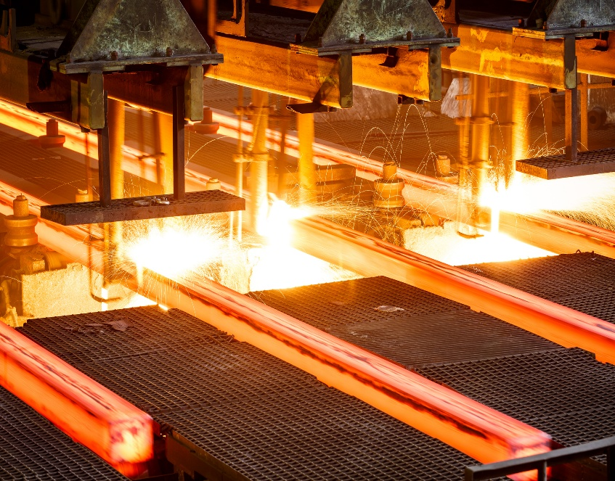
Task 4 India imposes temporary tariff on some steel to stem cheap imports from China
By Neha Arora and Surbhi Misra
April 21, 20254:19 PM GMT+2Updated April 21, 2025
India, the world's second-biggest producer of crude steel, on Monday imposed a 12% temporary tariff on some steel imports, locally known as a safeguard duty, to curb a surge in cheap shipments primarily from China.
A flood of Chinese steel in recent years has pushed some Indian mills to scale down operations and mull job cuts, and India is one of a number of countries to have contemplated action to stem imports to protect local industry.
The Ministry of Finance said in an official order that the duty would be effective for 200 days from Monday, "unless revoked, superseded or amended earlier".
The move is New Delhi's first big trade policy shift since U.S. President Donald Trump imposed a wide range of tariffs on countries in April, kicking off a bitter trade war with China.
Tensions over cheap steel imports into India predate that, with the investigation behind the latest move beginning in December.
India's Steel Minister H. D. Kumaraswamy said in a statement the measure is aimed at protecting domestic steel manufacturers from the adverse impact of a surge in imports, and will ensure fair competition in the market.
"This move will provide critical relief to domestic producers, especially small and medium-scale enterprises, who have faced immense pressure from rising imports," Kumaraswamy said.
Questions
- Who is the biggest threat to India’s steel industry?
- How is India proposing to protect its steel industry?
- Do you think India is justified in protecting its steel industry?

